Chapter – 10: Sound

* Lots of sound – every day – sound of vehicles, toys, machines, people, birds, thunder, etc
* Anything you hear – sound
* Sensitive ears – hear the smallest sound
* Sound – continuous disturbance – produce sensations – human ear
* These disturbances – called vibrations – travel – wave-like motion

# Internal and External Sounds

* Lots of sounds – chewing, swallowing, breathing, etc – inside, outside body
* Hear – tummy rumble (make some sound) – listen to heartbeat – stethoscope
* Most imp. sound – communicate with each other
* Everyone – at least one language – voices – share thoughts, ideas, feelings
* Animals – their own sets of sounds – dogs – howl, bark, growl, whimper
* Humans – fill surroundings with sound – playing music, television, etc
* Almost everything – makes sound – noisy world
* Any sound – 3 points –
  + Origin – what makes the sound?
  + Propagation – how does sound travel?
  + Perception – how do we hear sound?

# Origin of Sound

* Anything – solid, liquid, gas – create sound – vibrating objects
* Vibrations – carry energy – travel through air – like waves
* Louder the sound – bigger the waves or vibrations

## Vibrations produce sound

* Vibration – ‘to and fro’ motion – from mean position
* This motion – oscillation – movement of object – one extreme position to another and back
* Mean position to one extreme – from there to another extreme – back to mean position – also one oscillation
* Time taken – one oscillation – time period (t) – unit – seconds (s)
* Number of oscillation per second – frequency (f) – unit – Hertz (Hz)
* Maximum displacement – mean position to either side – amplitude (A)
* All sounds – vibrations – one or another part
* Stretch string – violin, guitar, sitar – produce sound
* Some instruments – membrane (skin) – stretch – vibrate along air – produce sound
* Scratch inflated balloon – stretched rubber vibrates – produce sound
* Blow air – empty bottle – air inside – vibrates – produce sound

## Sound produced by humans

* Sound – produced by us – vibrations – vocal cords – present in larynx (voice box)
* 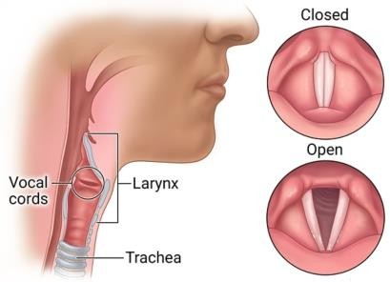Vocal cords – 2 bands of smooth muscle tissue
* Larynx – located in neck – top of the wind pipe
* Narrow passage – between cords – air pass
* Air pass through them – cords vibrate – produce sound
* Cords – attached muscles – make them – thick and loose
* Quality of sound – vey too much – when you hum – feel vibrations

## Sound produced by animals

* Some animals – dogs, cows, cats, etc – voice box – similar to humans
* Bees, housefly, etc – no voice box – vibrate wings – produce sound
* Frogs – inflate throat like balloon – produce sound
* Sound – falls on eardrums – they vibrate – brain interprets

# Propagation of Sound

* Sound waves – propagate (travel) – something vibrates
* Object – vibrates – disturbs air around it – air molecules – vibrates – gain some energy
* This energy – transferred to other molecules – close to them – starts a chain reaction
* This chain – called as sound wave
* Sound waves – travel through medium – source to listener
* Needs medium to travel – solid, gas, liquid – cannot travel in vacuum
* Speed of sound – depends on medium – fastest in solids – slowest in air
* Molecules in solids – closely packed – carry sound faster
* Telephone –
  + Mouthpiece of telephone – sound of voice – metal disc vibrates
  + Vibrations – changed to electrical signals – travel through wires
  + These signals – reach earpiece – another telephone – another disc vibrates
  + These vibrations – perceived (noticed) as sound by reciever

# Perception of Sound

* Sound – not visible – BUT – fill the surrounding – travel through air
* Ears, nerves, brain – help us to hear
* Night time – humming of insects – audible
* Recognise the voice of parents and friends – even if they are not in front
* Distinguish between different sounds – different sources
* Sounds – stored in memory – new sound received – brain compares it to memory – identify source
* Human ear – different parts – all have imp. roles –
  + Outer ear –
    - Outside part – pinna
    - Tightly stretched membrane – eardrum – separates outer ear from middle ear
    - Eardrum vibrates – sound waves reach it
  + Middle ear –
    - 3 bones – transmit vibrations to inner ear
  + Inner ear –
    - Consists – cochlea – receive sound vibrations – send message to brain – auditory nerve
* Sound enter through pinna – travels through ear canal – reach the eardrum
* Eardrum vibrates – waves amplified by bones – travel to inner ear
* These waves – received at cochlea – transferred to brain – electrical signals – through auditory nerves

# Audible and Inaudible Sound

* Vibrations – produce sound – BUT – human ear – hear frequencies – 20 Hz to 20,000 Hz only
* This range – audible sound – audible frequency range
* Bats – capable – hearing other sounds – beyond the range
* Sounds – not audible to humans – inaudible sound
* Dogs – upto 50,000 Hz – monkeys, leopards – above 20,000 Hz – bats – upto 1,20,000 Hz
* Sound – frequency > 20,000 Hz – ultrasonic – frequency < 20 Hz - infrasonic

# Echo and Reverberation

* Sound waves – also reflect – like light waves
* Sound wave – falls on surface – some – absorbed – rest – reflected
* Amount of reflection – depend on surface
* Sometimes – distance between source and surface – adjusted in such a way – sound heard again after reflection – called echo
* Shout near a valley – your voice – heard multiple times
* Reflecting surface – not at particular distance – no echo
* Multiple reflections – various surfaces – auditorium, etc – sound heard – even after source stops – known as reverberations
* Reverberation – produce beautiful effects – orchestra
* BUT – sometimes – multiple sounds – disturbing – difficult to hear speaker clearly
* Auditorium features – false ceiling – heavy upholstery (chair covers) – absorb more sound – reduce reverberations
* Navigators – use reflection of sound – check depths OR position of submarines
* Ultrasonic waves – used for this – SONAR – Sound Navigation and Ranging

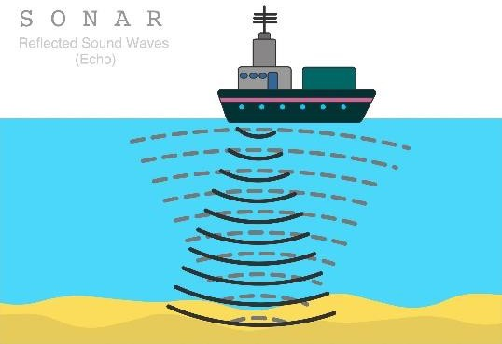

# Characteristics of Sound

* Loudness –
  + Sound – gets louder – when more energy enters our ear
  + Source – vibrates with larger amplitude
  + Guitar string – pull more strongly – amplitude increases
  + Note – much higher – more energy
  + Loudness – expressed in decibels (dB)
  + Produced sound – travels in all directions – like a ripple in water
  + Stand at a place – part of sound heard – BUT – sound beamed at you – hear whole sound
  + People – make a cup with hands – behind ear – make a funnel – catch more energy
  + Sometimes – people also use microphone
* Pitch –
  + Sharpness of sound – pitch
  + Sound waves – high frequency – high pitch – low frequency – low pitch
  + Musical sound – specific pitch – notes
  + Set of tuning forks – different frequencies – produce different frequencies
  + Tuning fork – 2 prongs (metal pieces) – vibrate when struck – move in and out together
  + Pitch of sound – decides sharpness – voice of child – much sharper – higher frequency
  + Factors affecting pitch –
    - Length –
      * Size of instruments – affects – pitch of notes
      * Instruments – guitar, violin, etc – longer string – lower pitch
        + Double bass – lower notes than violin
      * Instruments – flute, etc – cover, uncover holes – length of air column changes – notes changes
    - Thickness –
      * Guitar, violin – strings – different thickness
      * Thicker strings – heavier – do not vibrate quickly – lower pitch
    - Volume of air or liquid columns –
      * Greater volumes – lower notes
      * Example – flute
* Quality –
  + Quality (timber) – another characteristics – distinguish between sounds – same pitch, same loudness
  + Sounds from different instruments – sitar, guitar, etc – differ in quality
  + Quality – depends on part of instrument – vibrates and produce sound
  + 2 people – identical vocal cords – voices – non-identical – different sound qualities
    - Reason – quality of sound – depend on shape of source – mouth cavity, tongue, teeth, etc

# Musical Instruments

* Work – making sound waves
* Shape, size, material – affects the sound
* Some instruments – sounds box – resonates – vibrates at same frequency as the original sound – sound gets fuller, richer
* Divided into following groups –

## Stringed instruments –

* + Instruments – violin, guitar, sitar, veena, harp, etc – stretched strings – vibrate – pluck them
  + Piano – string vibrates – hit by hammers – controlled by keys
  + More vibrations – louder sounds
  + All instruments – different thickness, tension of strings, length of strings – different sounds

## Wind instruments –

* + Work – column of air – vibrates inside
  + Vibrations produced – different ways
  + Trumpet – player’s lips – vibrate – cup-shaped mouthpiece
  + Sound – amplified (made louder) – tube and flared (widened) end
  + Flute, nadaswaram – wind instruments

## Percussion instruments –

* + Work – beaten, scrapped, shaken
  + Drum – tight skin – beat with hand, stick, etc – produce vibrations
  + Vibrations – air inside drum vibrates – hollow shape amplifies sound
  + Other instruments – majira (cymbals), mud pots
  + These instruments – commonly used – different parts
  + Bell, jal tarang – examples
  + Jal tarang – different bowls – different amount of water – stuck with stick – musical sound produced

## Electrical instruments –

* + Electric guitar – small sound vibrations by strings – amplified by electronic amplifier
  + Sound – changed to electric signals – change back to sound after amplification

# Music and Noise

* Music –
  + Sound – regular pattern – made by instruments
* Noise –
  + Unwanted, irritating sound – clattering, banging, drills, badly played music – irregular patterns
* Most people – recognise music – BUT – music – different for everyone

# Minimizing Noise Pollution and its Hazards

* Unpleasant sound – noise – presence of noise – noise pollution
* High pitched noise – more annoying
* Noise pollution – damage ears and other hearing problems
* Common causes – flying aircraft, moving vehicles, loud music, machinery, etc
* Reduction methods –
  + Fitting silencers – vehicles
  + Sound-insulating (absorbing) materials – curtain, carpet, etc
  + Trees – between house and road
  + Ear protectors – minimize noise effects – factory workers, truck drivers, etc
  + Insulating noisy rooms – air gap between walls – sound does not travel